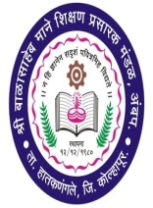 | Shri Balasaheb Mane Shikshan Prasarak Mandal Ambap’s  ASHOKRAO MANE INDUSTRIAL TRAINING INSTITUTE, VATHAR TARF VADGAON  Tal.Hatkanangle,Dist.Kolhpur-416 112 (Maharashtra)  Office:(0230) 2407760 Fax: (0230) 2407750  Website:-www.ampiti.com, Email:ampitiv@gmail.com  DVET ITI CODE : 4012 NCVT MIS CODE :PR27000990 EST. YEAR 2019-20

Faculty Name : Mr.Vikram Sarjerao Surve 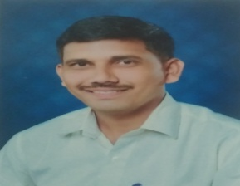

Faculty Designation : Lecturer

Highest Qualification : BE Civil

Experience Teaching Years : 2Years

Experience Industrial : 3 Years

Additional Information : No

Date of Appointment : 23/09/2021

Subjects Taught : 22301,22303,22503

Training Attended In Last 2 Years : No

Conference/ Seminars/Workshops Attended: No

Paper Published : No

Research /Development Projects Undertaken: No

